Chapter-7

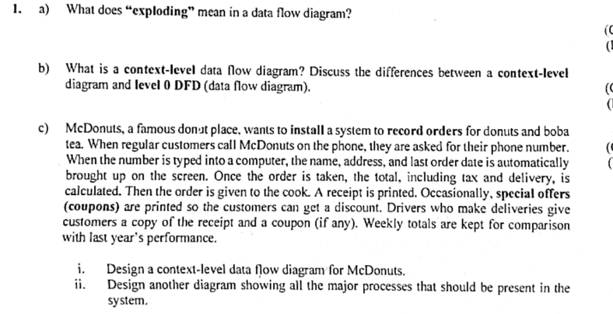

* ~~Data Flow Diagrams~~
* ~~Advantages of the Data Flow Approach~~
* ~~Basic Symbols~~
* ~~External Entities~~
* ~~Data Flow~~
* ~~Process~~
* ~~Data Store~~
* ~~Steps in Developing Data Flow Diagrams~~
* ~~Creating the Context Diagram~~
* ~~Basic Rules~~
* ~~Drawing Diagram 0~~
* ~~Data Flow Diagram Levels~~
* ~~Creating Child Diagrams~~
* ~~Differences between the Parent Diagram (above) and the Child Diagram~~
* ~~Checking the Diagrams for Errors~~
* ~~Logical and Physical Data Flow Diagrams~~
* ~~Features Common of Logical and Physical Data Flow Diagrams~~
* ~~The Progression of Models from Logical to Physical~~
* ~~Developing Logical Data Flow Diagrams~~
* ~~Developing Physical Data Flow Diagrams~~
* ~~Event Modeling and Data Flow~~

Diagrams

* ~~Event Response Tables~~
* ~~Use Cases and Data Flow~~

Diagrams

* ~~Partitioning Data Flow Diagrams~~
* ~~Reasons for Partitioning~~
* **~~Partitioning Web Sites~~**
* **~~Communicating Using Data Flow Diagrams~~**
* **Summary**

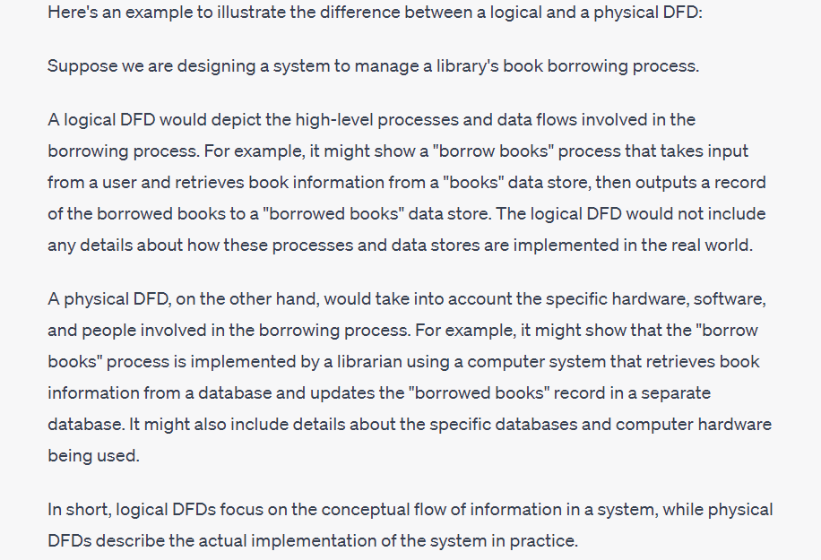

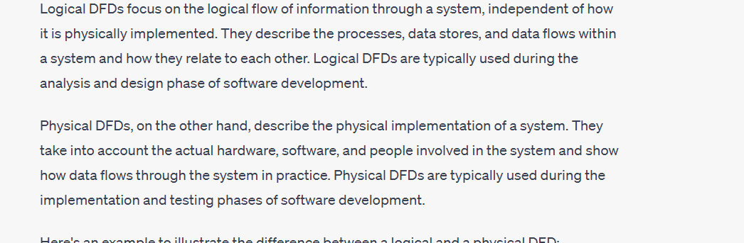

Chapter-10

* ~~CRC Cards and Object Think~~
* The Unified Modeling Language

(UML) Concepts and Diagrams

* ~~Things~~
* ~~Relationships~~
* ~~Structural Relationships~~
* ~~Behavioral Relationships~~
* Use case Diagrams
* Activity diagram
* Sequence
* Uml
* 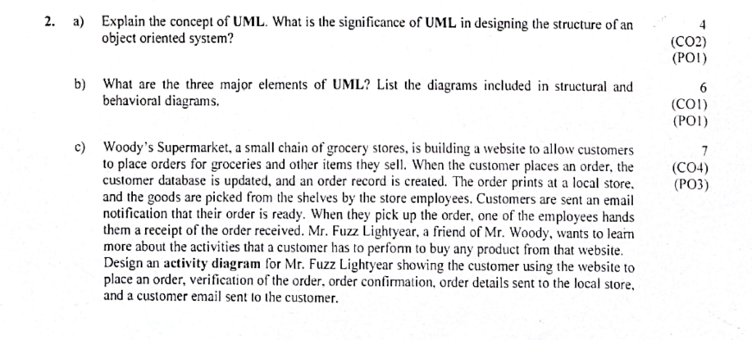

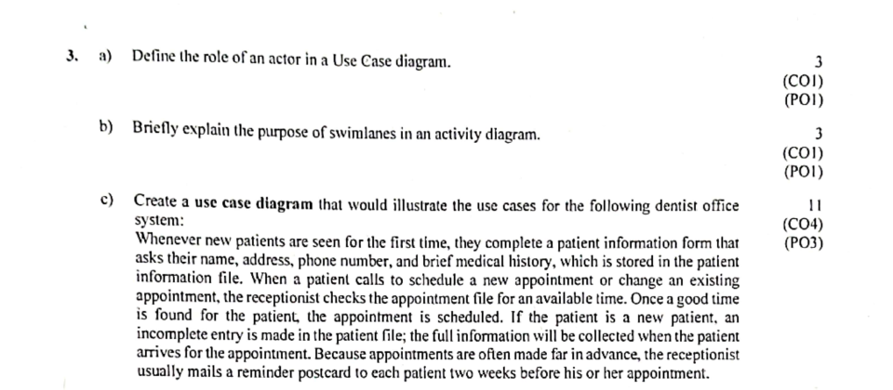

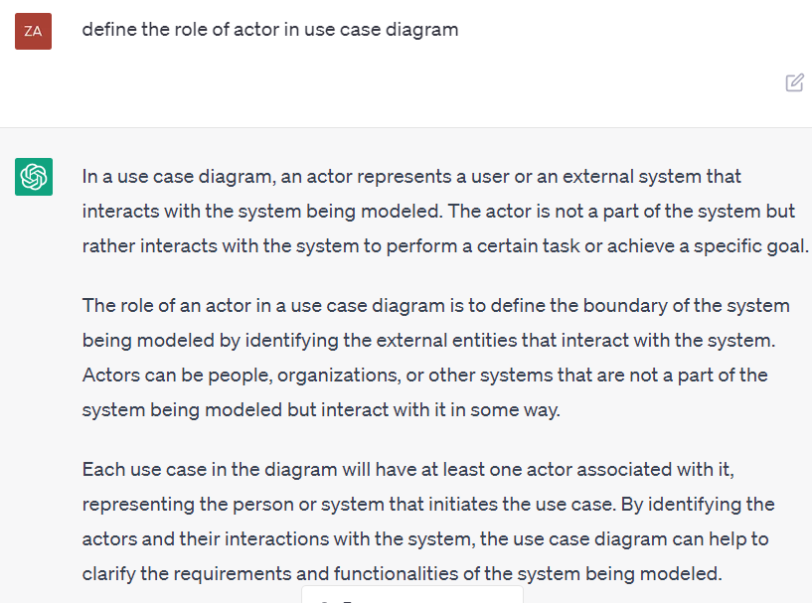

Chapter-6

* Agile Modeling, but First Prototyping
* Prototyping
* • Patched-up
* • Nonoperational
* • First-of-a-series
* • Selected features
* Prototyping as an Alternative to the Systems Life Cycle
* Guidelines for Developing a Prototype
* Disadvantages of Prototyping
* Advantages of Prototyping
* Prototyping Using COTS Software
* Users’ Role in Prototyping
* Rapid Application Development,RAD Phases
* Requirements Planning Phase
* RAD Design Workshop
* Implementation Phase
* Comparing RAD to the SDLC
* When to Use RAD
* Disadvantages of RAD
* Agile Modeling,Values and Principles of Agile Modeling
* The Basic Principles of Agile Modeling
* Activities, Resources, and

Practices of Agile Modeling

* Four Resource Control Variables

of Agile Modeling

* Four Core Agile Practices
* The Agile Development Process
* Writing User Stories
* Scrum
* Lessons Learned from Agile

Modeling

* Comparing Agile Modeling and

Structured Methods

* Risks When Adopting New Information Systems